《计算机科学导论》实验报告
实验四 HTML网页设计

班级：计算机241
姓名：陈周豪
学号：1120242118

目 录
1 网站设计 3
2 网站源代码 3
2.1 首页代码 3
2.2 第二页代码 6
3 网站运行效果 9
4 实验总结 9

1 网站设计
实现一个登录页和个人网站主页，用到了CSS+HTML+JS，做了一个静态界面。

2 网站源代码
包含两个页面，采用内联样式直接将css写在html内。

2.1 首页代码
<!DOCTYPE html>
<html lang="en">
<head>
<meta charset="UTF-8">
<meta name="viewport">
<title>Login</title><script>
function valform(){
var username=document.getElementById("Username").value;
var password=document.getElementById("Password").value;
sessionStorage.setItem('username',username);
if(username!=="admin"){
alert("Account no exsited!");
event.preventDefault()
return false;
}if(password!=="nopassword"){
alert("Wrong password!");
event.preventDefault()
return false;
}
return true;
}</script>
<style>
body {
font-family: 'Gill Sans','Gill Sans MT',
Calibri,'Trebuchet MS',sans-serif;
background-image: url(./backgronud-img.jpg);
background-size: cover;
background-position: center;
background-repeat: no-repeat;
display: flex;
justify-content: center;
align-items: center;
height: 100vh;
margin: 0;
}
.welcome-text{
display: flex;
justify-content: center;
font-size: 28px;
font-family: 'Gill Sans','Gill Sans MT',
Calibri,'Trebuchet MS',sans-serif;
color: #07536f;
font-weight: bold;
margin-bottom: 20px;
}

.login-container {
background-color: rgba(255, 255, 255, 0.6);
padding: 30px;
border-radius: 10px;
box-shadow: 0 4px 8px rgba(0, 0, 0, 0.1);
width: 300px;
text-align: center;
}
.login-container h2 {
margin-bottom: 20px;
font-size: 24px;
color: #07536f;
}

.input-field {
width: 100%;
padding: 10px;
margin: 10px 0;
border-radius: 5px;
border: 1px solid #ccc;
box-sizing: border-box;
font-size: 16px;
}
.login-button {
width: 100%;
padding: 10px;
background-color: rgb(22, 186, 198);
color: white;
border: none;
border-radius: 5px;
font-size: 16px;
cursor: pointer;
}
.login-button:hover {
background-color: rgb(8, 83, 113);
}

.forgot-password {
font-size: 14px;
color: #a3a4a6;
text-decoration: none;
margin-top: 10px;
}
.forgot-password:hover {
text-decoration: underline;
cursor: pointer;
}
</style>
</head>
<body>
<div>
<div class="welcome-text">
Welcome to Ada's Website!
</div>
<div class="login-container">
<h2>Login in</h2>
<form onsubmit="return valform(event)" action="./index.html">
<input type="text" id="Username" class="input-field"
placeholder="Username" required><br>
<input type="password" id="Password" class="input-field"
placeholder="Password" required><br>
<button type="submit" class="login-button">
Submit</button>
<a class="forgot-password" href="#">
forgot password?</a>
</form>
</div>
</div>
</body>
</html>

2.2 第二页代码
<!DOCTYPE html>
<html lang="en">
<head>
<meta charset="UTF-8">
<meta name="viewport">
<title>personal-page</title>
<style>
body {
font-family: 'Arial', sans-serif;
margin: 0;
padding: 0;
background: linear-gradient(135deg, #8fe4f3 0%, #2575fc 100%);
color: rgba(251, 251, 251, 0.6);
line-height: 1.6;
}
header {
text-align: center;
padding: 50px 0;
background-color: rgba(88, 120, 129, 0.7);
}
header h1 {
font-size: 3em;
margin: 0;
color: #fff;
}

.container {
width: 90%;
max-width: 900px;
margin: 50px auto;
padding: 40px;
background-color: rgba(255, 255, 255, 0.4);
border-radius: 15px;
box-shadow: 0 10px 30px rgba(0, 0, 0, 0.1);
color: #333;
transition: transform 0.3s ease, box-shadow 0.3s ease;
}

.container:hover {
transform: translateY(-10px);
box-shadow: 0 20px 40px rgba(0, 0, 0, 0.2);
}
.profile-img {
width: 150px;
height: 150px;
border-radius: 50%;
object-fit: cover;
margin-bottom: 20px;
border: 5px solid #15afaa;
box-shadow: 0 0 10px rgba(0, 0, 0, 0.2);
}
h2 {
font-size: 2em;
margin: 10px 0;
color: #333;
}
p {
font-size: 1.1em;
margin-bottom: 15px;
color: #213096;
}
ul {
list-style: none;
padding: 0;
}
ul li {
font-size: 1.1em;
margin: 8px 0;
}
ul li a {
text-decoration: none;
color: #157eb3;
transition: color 0.3s ease;
}
ul li a:hover {
color: #12879e;
}
footer {
background-color: rgba(66, 103, 224, 0.8);
color: white;
text-align: center;
padding: 5px;
position: fixed;
width: 100%;
bottom: 0;
}
.fade-in {
animation: fadeIn 1.5s ease-in-out;
}
@keyframes fadeIn {
0% { opacity: 0;
}
100% { opacity: 1;
}
}
@media (max-width: 768px) {
header h1 {
font-size: 2.5em;
}
.container {
padding: 20px;
}
.profile-img {
width: 120px;
height: 120px;
}
}
</style></head>
<body>
<header class="fade-in">
<h1>Hello!</h1></header>
<div class="container fade-in">
<img src="./profile-img.jpg" alt="pic" class="profile-img">
<h2>Hi,I'm AdaYusal</h2>
<p>I'm dreaming to be a web-engineer and a GUI maker.</p>
<p>My skill: HTML\CSS\JavaScript&Node.js and C/C++.</p>
<p>If you have any problem,please link to me!</p>
<ul><li>Email: pomrcoji@gamil.com</li>
<li><a href="https://github.com/aumiit"
target="_blank">Github: aumiit</a></li>
<li><a href="https://space.bilibili.com/448724205"
target="_blank">BiliBili: AdaDuzi</a></li>
</ul></div>
<footer><p>Why you look here?</p></footer>
<script>
var username=sessionStorage.getItem('username');
var h1Element=document.querySelector('h1');
h1Element.textContent='Welcome,'+username+'!';
</script>
</body></html>

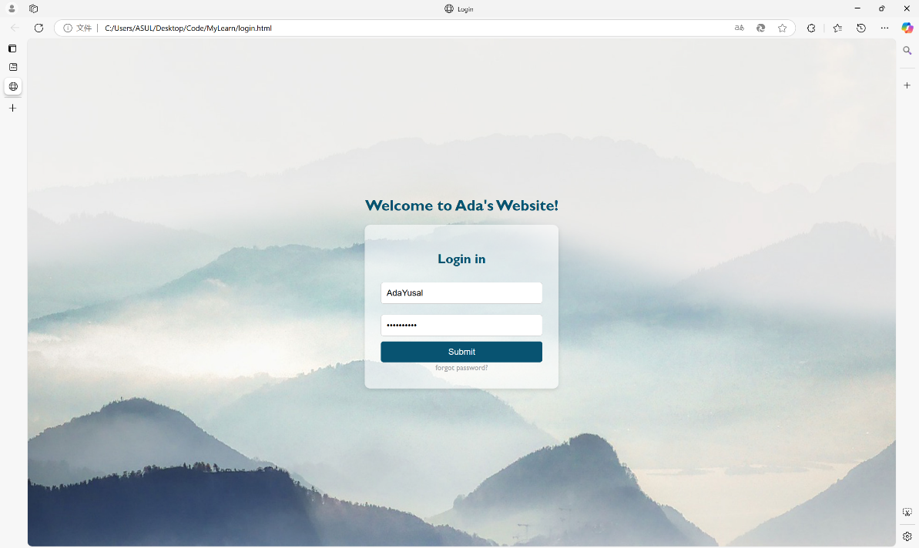
3 网站运行效果
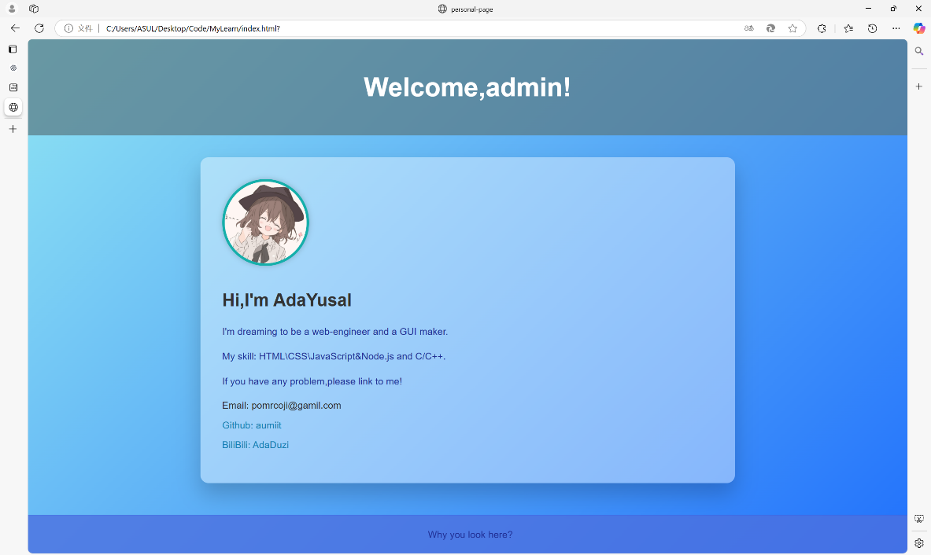
图3-1 登录页
图3-2 主页

4 实验总结
学习了如何使用html/css/js制作了两个静态页面包括登录页和个人主页，实现用js验证登录并跳转和在个人主页介绍个人信息，利用html和css给页面布局和美化，帮助我了解了网页的基本组成。

